Requirement Details

Client : Karassery Service co-operative bank
Task ID : 664167 -1

Requirement Study Details

Conducted By : Praveena
Module : My Bank
Date : 01-07-2024

Requirements Summary: -

Requirement:

Automatic Pre-Approved Gold Loan Integration in 'My Bank Application'

Detailed description:
- Display the maximum loan amount based on the gold packet's valuation.
- Customers should be able to select from eligible gold packets.
- Loan Renewal Option:
- Renew with Additional Loan: Reassess the gold packet's current value, offer the customer an additional loan based on the difference in value, if any.
- Renew without Additional Loan: Simply renew the loan for another term without changing the loan amount.
- Upon approval, the loan amount should be credited directly to the customer’s account instantly.
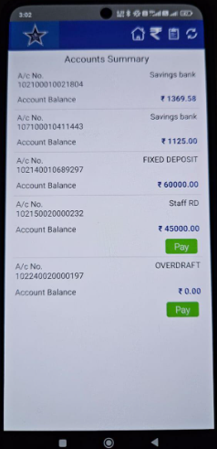
- Configure SMS and email notifications that inform the customer about the disbursal or renewal, including key details like loan amount, interest rate, tenure, and due date

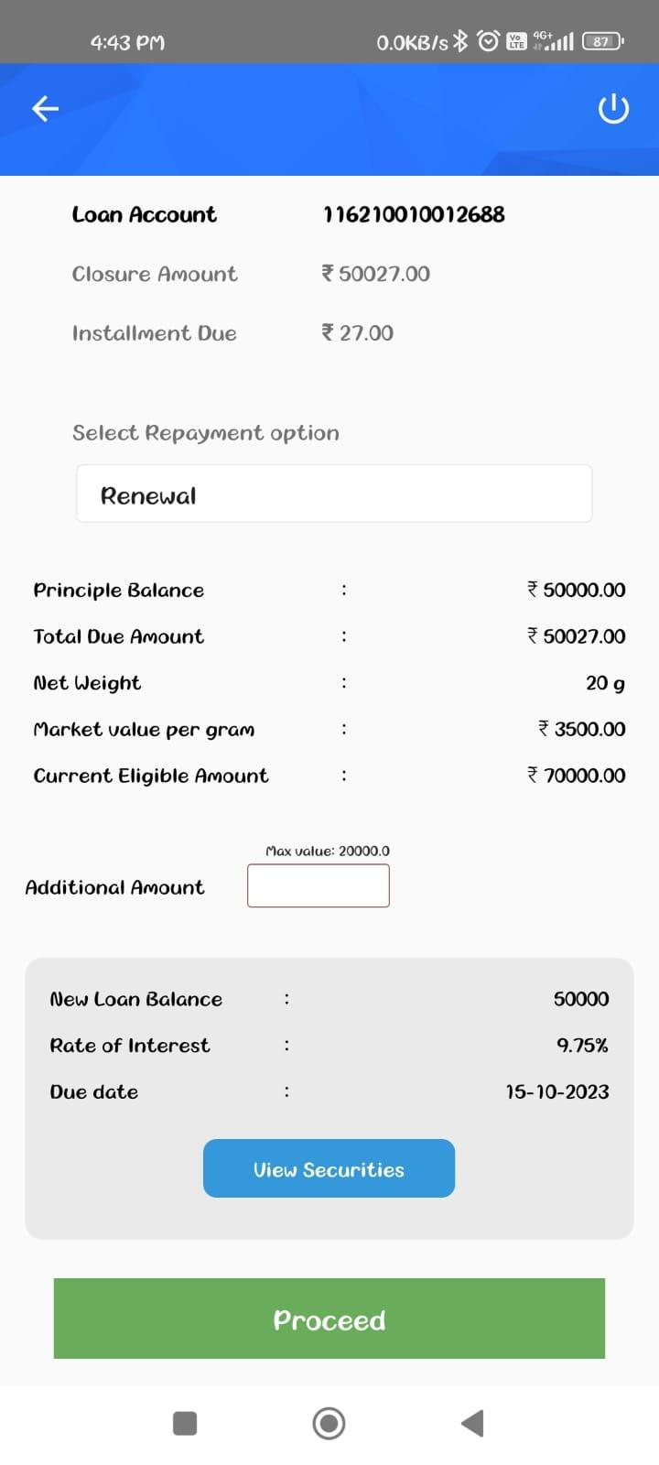
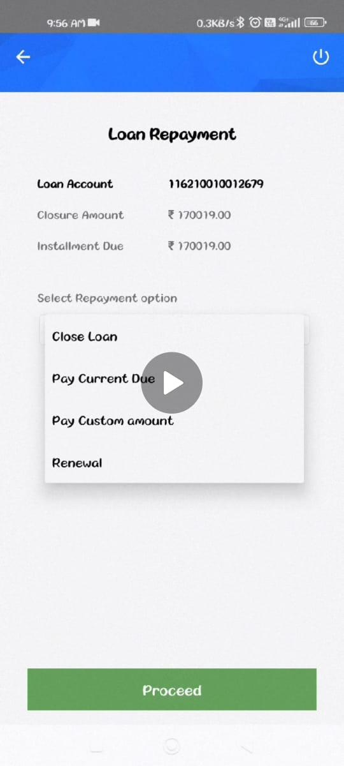

Supporting Documents

Product Manager Note

CR:YES/NO | PAID :No
Work Around Description

Development Lead Note

Estimation in Hours

Clarification Points

